& OLYMPIC

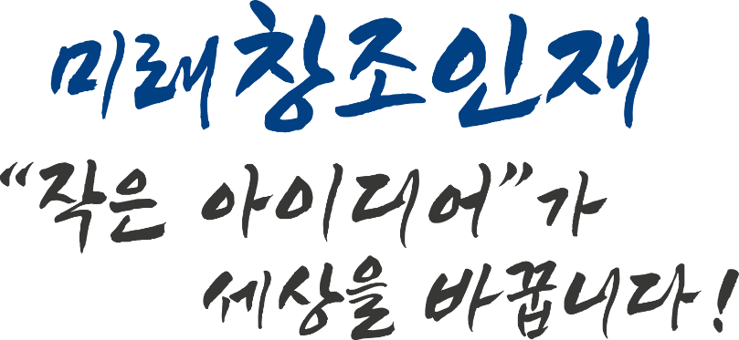

ICPC Organizing Committee
Ⅰ | Academic Outline

1. Purpose
ICPC (International Creative Papers Conference) and Olympic is an academic conference where domestic and foreign researchers present their creative research. The purpose is to publish and exchange excellent papers by world scholars who will play a pivotal role in the knowledge economy.

The ICPC, which aims to lead the ESG convergence conference of world science and technology and economic activity by publishing creative and autonomous research and study thesis, is an international conference in which 20 countries participate. It is an international academic event jointly held by the Invention Association and domestic and foreign universities and societies.

In addition, published materials are published in ISSN (International Standard Serial Number) international standard publications and research results are given.

2. Schedule
Division | Progress Schedule | Method | Note
Announcement  Contest | *Oct 10 (Mon) 2022 ~ | SNS, contests  etc. | www.invent21.com
Application Period | ~ Jan 20 (Fri) 2023 | Online | Seoul, COEX  and external event venues  (expected)
Classification Review | *Jan 29 (Sun) ~  Jan 30 (Mon) 2023 | Contry—by-Country
Presentation of a thesis  > Seminar (Forums) | *Feb 03 (Fri) 2023  AM : 09:30 ~ 12:00  PM : 12:00 ~ 17:00 | Announcement by Session
 | *Feb 04 (Sat) 10:00 ~ 12:00 | Seminar (Forums)
 | - Feb 04 (Sat) 12:00 | Lunch
 | *Feb 04 (Sat) 13:00~ | Award Ceremony

Ⅱ | Participation Application

1. Eligibility to Participate
○ Student Dept. (Invention paper) / General Dept. (Adults)
* Local and foreign students, leaders (authors of thesis etc.) / by individual or team
* Local and foreign professors and student(researchers)
2. Classification (Forms are not limited: Free-form)
○ Advanced technical papers such as inventions, patents, etc.
○ Research papers on new technologies following the 4th industrial revolution
○ ESG management and humanities, etc.
○ Abstract of published thesis or invention(patent)

3. Paper Field
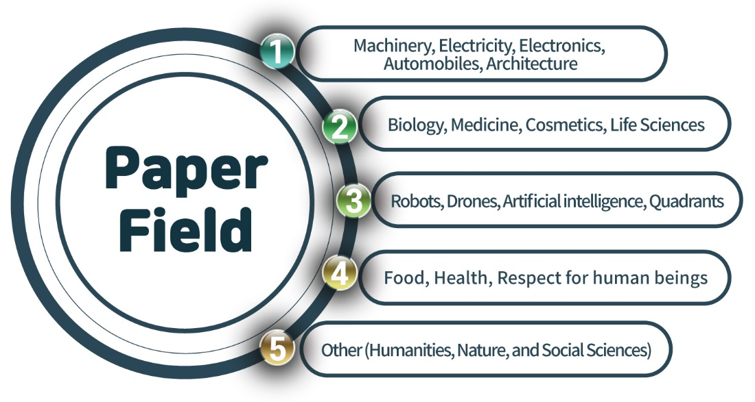
* 5 includes ESG management, humanities and social sciences, and economics
4. Application Reception
○ Application : By E-mail
- Lee37895661@gmail.com (please attach the thesis)
○ How to download the application form
- Download from www.wicokorea.com > ICPC
www.invent21.com > Domestic exhibition > ICPC
5. Cautions
○ Do not write over 5 pages (You can include the photos).
○ Presentation time within 10 minutes (Power point or poster)
– within 5 minute of Q&A by each committee

Ⅲ | Judgement and Award Plan

1. Standards of Judgement (According to the rules and emphasizing presentation skills)
Category | Poor | Average | Good | Very Good | Excellent
Creativity and Skill | 1 | 2 | 3 | 4 | 5
Feasibility of research(Invention) method | 1 | 2 | 3 | 4 | 5
Relevance between theory and practice | 1 | 2 | 3 | 4 | 5
Presentation Application | 1 | 2 | 3 | 4 | 5
2. Contents about Awards
Category | The Award Type | Award details | Notes
Prize for  theses | Grand Prize | Prize money, Prizes, medals and trophies | Duplicate awards are available for additional announcements by sector.  * duplicate awards possible
 | Gold Medal
 | Silver Medal
 | Bronze Medal
 | First Prize for presentation
 | Total

3. Special benefits for Winners
- Support the participation in global academic conferences
- Academic network and Research Activities Certification
- Additional points for WICO (World Invention Creativity Olympics) international competition participants
- ISSN(International Standard Serial Number) Publication of international standard publications

4. Cautions about theses and Method of submission
❍ ICPC allows theses of creative inventions, Not SCI or SSCI paper.
❍ When producing a research thesis presentation, you are responsible for the copyright protection of the presenter’s photo and work photo.
❍ Responsibilities of the published research data in case of any legal problems

5. Participation expenses and thesis review expenses
Category | Review Fee | A collection of papers | Lunch | Total
Foreigner | 400 (USD) | 100 (USD) | - | 500 (USD)
* Additional certificates of award and medals for those who participate in a team can be purchased at $100
* Lunch is for One person Free

6. Deposit Account
Official Name of Bank | INDUSTRIAL BANK OF KOREA  (BIC, SWIFT CODE : IBKOKRSE
Adress | 18, Hyoryeong-ro 53-gil, Seocho-gu, Seoul, Korea
Beneficiary | 055-059806-56-00011
 | Lee, Ju Hyung

