

**INVITATION**

**Dear** : Agent & Inventor

**Welcome to 2023, The 12th World Invention Creativity Olympic (WICO).**

I really want to meet you in Seoul in 2023. The 12th WICO will be held at SETEC in Seoul from July 27 to 29, 2023. If it is difficult to visit Korea due to COVID-19, face-to-face and non-face-to-face screening will be conducted together. We will provide maximum convenience to you who visit to participate in WICO.

Meanwhile, this event encourages creative ideas, provides new insights, accelerates one’s creativity, improves presentation skills and establishes a global network. Besides, you can jointly research core technologies

the fourth industry in search of new items, and the company can become a global market leader of patent product transactions where buyers can promote products through consultation.

The deadline for application is Saturday, June 10, 2023.

Yours sincerely,

2023. 03

|  |  |
| --- | --- |
|  | **Ph.D Economics & Engineering / Lee Ju hyung**  ∙ Kongju National University / Professor  ∙ Korea University Invention Association / PresidentRepublic of Korea  ∙ Asia Lohas Industry Certification Association / President |

**1. Application and Reception**

|  |  |
| --- | --- |
| Application period | ~ June 10 (Sat) 2023 |
| Method of reception | 1. 7935111@ naver.com (KOREN) |
| 1. Lee37895661@ gmail.com (Foreign) |

**2. Schedule**

|  |  |
| --- | --- |
| Exhibition & International Review | July 27 (Thur) ~ 29 (Sat) 2023 |
| Awards Ceremony (Participant) | July 29 (Sat) 2023 |

**3. Participation Classification**

|  |  |  |
| --- | --- | --- |
| **Age Group** | | **Award** |
| Student | Elementary, Middle, High, and College Students | Grand Prix Award, Gold, Silver, and Bronze |
| Individuals / Companies | Corporate Products | Grand Prix Award, Gold, Silver, and Bronze |

**4. Evaluation Criteria**

|  |  |  |  |
| --- | --- | --- | --- |
| **CRITERIA** | **DESCRIPTION** | **Prior Judge** | **Final Judge** |
| **IDEA** | Creative and Innovative. | 50 | 30 |
| **Technology** | Different from existing technology and progressive. | 20 | 20 |
| **Practicality** | It has high commercial potential | 30 | 0 |
| **Presentation** | Explaining features clearly and comprehensively, answering questions well. | 0 | 50 |
| **Total Score** | | 100 | 100 |

**5. Award Planning**

|  |  |
| --- | --- |
| **Main Prize** | Grand Prix (1%) Gold Award (29%) / Silver Award (40%)  / Bronze Award (30%) |
| **Special Award** | K - Edison Award : 1 Item by item  Special Offshore Prize : Special Award of the International Institute of Inventions |

**\*** Select one of the best inventions in each field Edison Award

**6. Fee**

**1. Member (Wiipa. IFIA. WIPO. Other WICO authentication) (*Foreigners only)**

|  |  |  |
| --- | --- | --- |
| **Entry Fee** | **Students / (One) invention)** | **Corporation** |
| **Member &** **agency** | USD450 / each | USD 900 / each |
| **Not a member** | **USD 900 / each** | |

* Additional certificates of award and medals for those who participate in a team can be purchased at $100

* Shipping cost **USD 100~200** **(consultation by country)**

**7. Poster and Exhibition method (SAMPLE) (예정)**

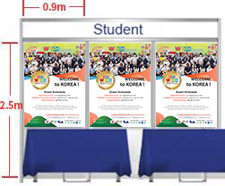 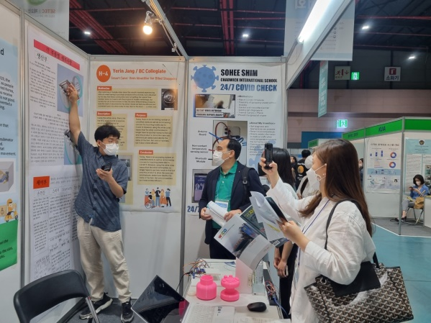

|  |
| --- |
| Poster Size : 0.9m x 1.5m / Independent booths have separate consultations |

**8. Deposit Account**

|  |  |
| --- | --- |
| **Official Name of Bank** | INDUSTRIAL BANK OF KOREA  (BIC, SWIFT CODE : IBKOKRSE |
| **Adress** | 18, Hyoryeong-ro 53-gil, Seocho-gu, Seoul, Korea |
| **Beneficiary** | 055-059806-56-00011 |
| Lee, Ju Hyung |

**9. Exhibition Location**

|  |  |
| --- | --- |
| **Seoul Trade Exhibition & Convention, Exhibition Hall 2** | |
| **ADDRESS** | 514 Daechi-dong Seoul, Korea |
| **SUBWAY** | Line 3, Hangnyeol Station Exit 1 |
| **WEBSITE** | www.setec.or.kr |

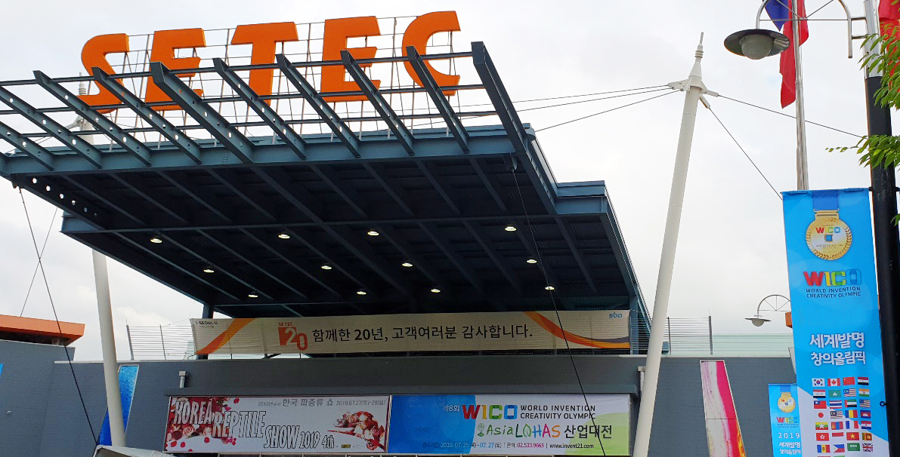

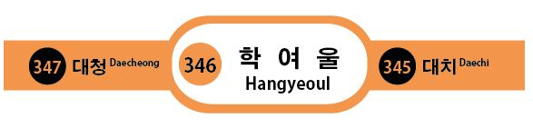

**10. Organiser Contact info**

**Website :** [**www.wicokorea.com**](http://www.wicokorea.com) **/** www.invent21.com / www.asialohas.org

**E-mail :** 7935111@naver.com / Lee37895661@gmail.com

**Tel :** +82 10 3789 5661

